**B9IS103 Computer Systems Security**



Module Lecturer: Pete Cassidy

***Computer Systems Security Continuous Assessment Task***

By:

Sharon Farrell - 10581193

Shastri Telikicherla - 10606539

Mohammed Ghouse Khan - 10614532

**Table of Contents**

1. PART A: Setting up Linux (Kali) & DVWA environment ….………………………………...……….3
2. PART B: Using the DVWA………………………………….….…...….………………………………...……….3
   1. Vulnerabilities within DVWA
   2. Description of vulnerability
   3. Solutions for protection against
3. PART C: Social Engineering Attack with Kali Linux ….………………………………...……….3
   1. Website cloning attack
   2. Software Engineering Toolkit
   3. Output from SET

**PART A: Setting up Linux (Kali) & DVWA environment**

Screenshots from Oracle virtual box Kali:

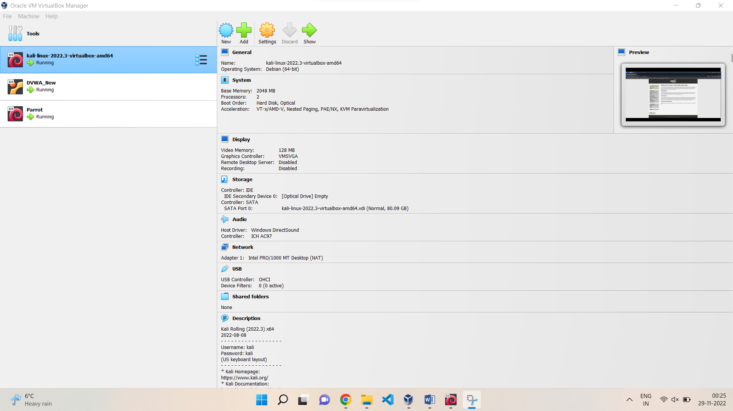

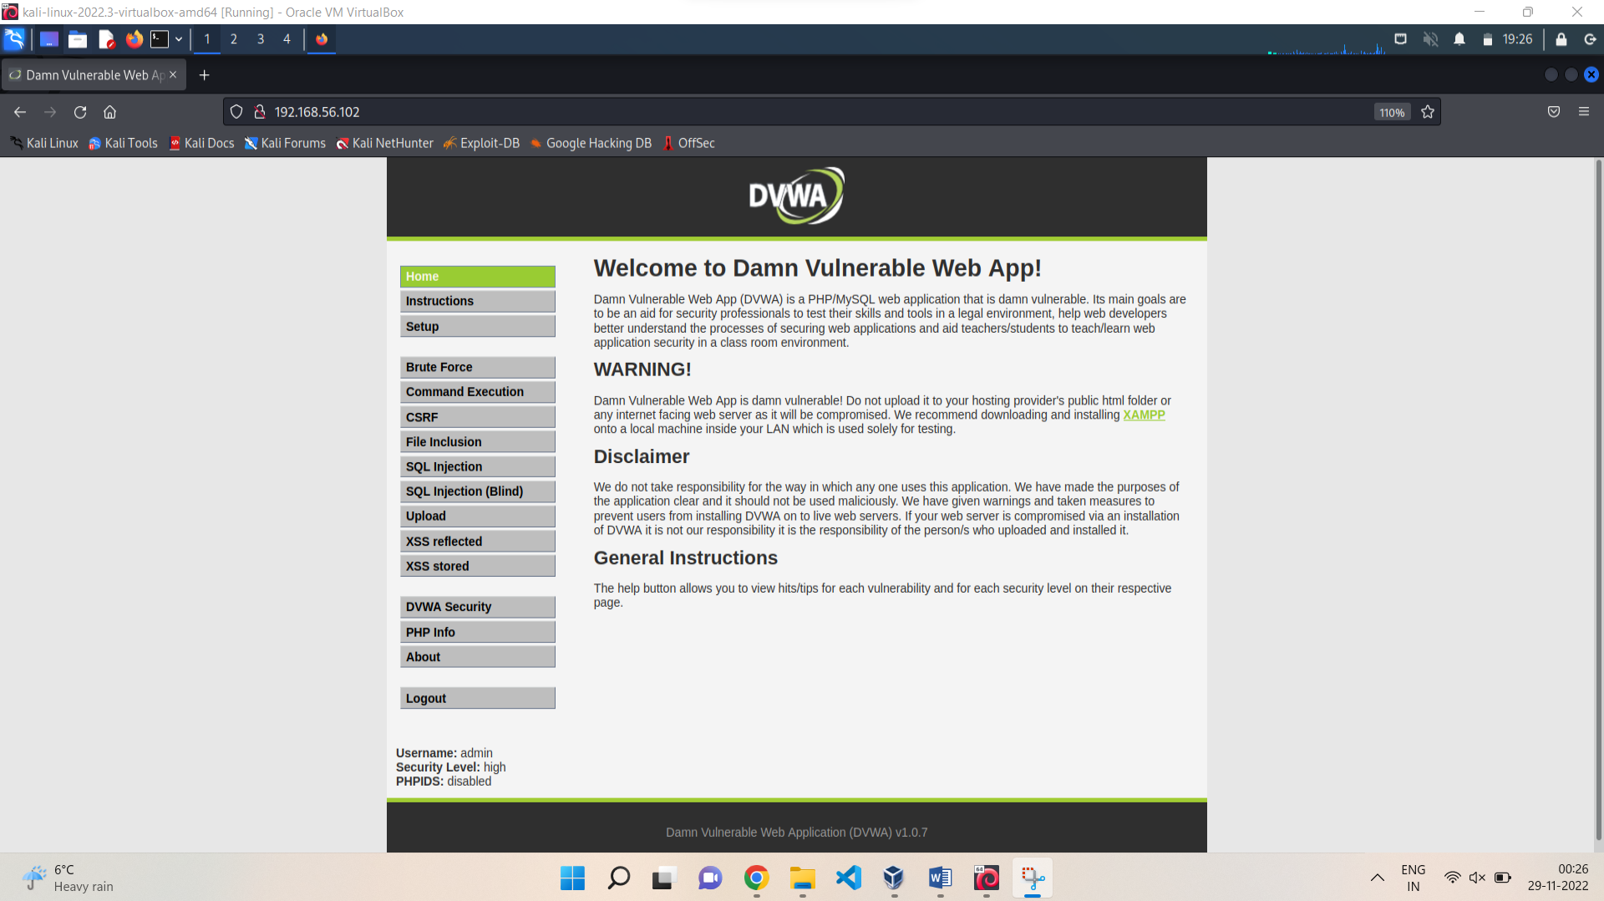

Screenshots from Oracle virtual box DVWA:

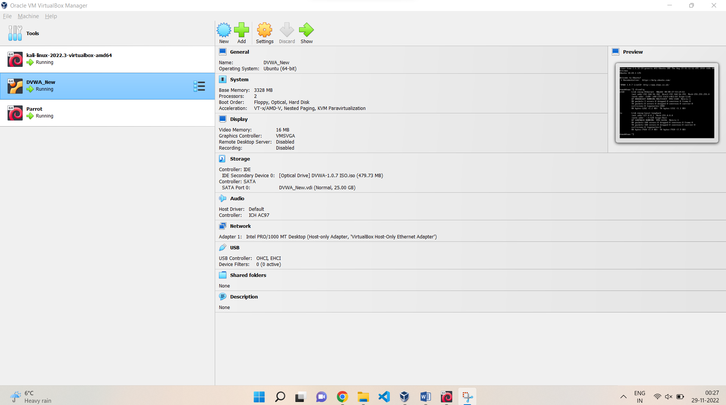

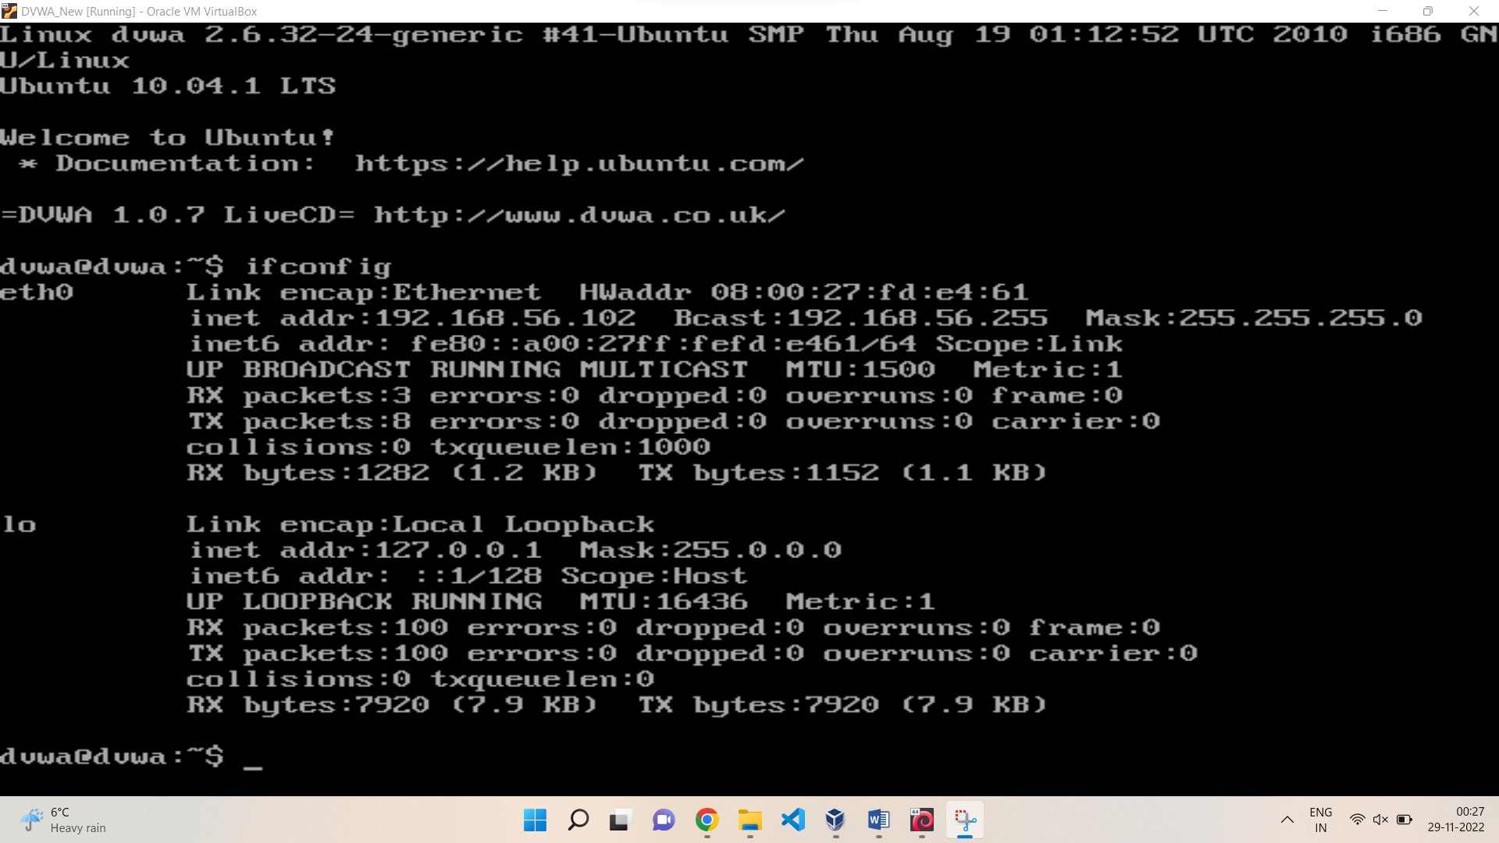

Screenshots from Oracle virtual box Parrot:

